Dear Ian,

RE: Genetic microarrays to assess disease progression in patients with a history of diagnosis and treatment for early (T1/T2 NO/N1) oral squamous cell carcinoma – a preliminary study.
Grant requested: £ 9980

This is the interim progress report for the research funded by the above grant. I would like to mention that there was some delay in starting this project due to some difficulty relating to locating the cheque for the relevant account.

However, following a detailed examination of 200 patients we identified 13 patients so far that are suitable to be included in this work. These are patients that have had an area of dysplasia that progressed to oral squamous cell carcinoma (SCC) or a primary squamous cell carcinoma and recieved the relevant treatment before 2010. These 13 patients have now developed another squamous cell carcinoma several years later. Their tissue blocks were identified for DNA sequencing.

18 slides have been prepared so far of the more recent SCC and our expert pathologist has marked the relevant areas.

The expenses so far involve:

- Histology part of work (18 samples) £145.60 (for original SCC)
- Histology part of work (18 samples) for most recent SCC £145.60
- DNA extraction £324

So far we have extracted DNA data for the dysplasia and the primary cancer for every patient. The next part of this work will involve obtaining DNA data of their more recent SCC for comparison.

So just to give you an example of what we have so far, please see the diagram below. We now have DNA data for all of these 13 patients for the first cancer as well as any areas of dysplasia. This example is patient 123.

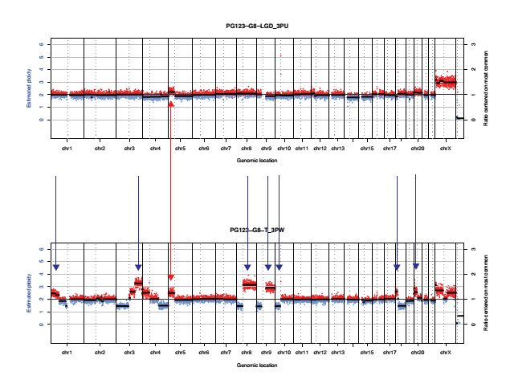

This is genomic copy number data, so the x axis is genomic position and the y axis shows gain (red) and loss (blue) of parts of chromosomes. Regions with a mixture of blue and red dots are normal. This example is PG123. The top plot is from a dysplasia sample, the bottom is SCC. The red arrow I’ve drawn between the two is a gain in chromosome 5 which is shared, showing that the SCC has descended from the dysplasia. The blue arrows are new things that the SCC has developed.

We will be getting new data like this from the same patient, from the second SCC, the one that occurred several years later. We hope to be able to make conclusions once we have all the data. We will look at detailed mutations in the very near future. Details of the expenses for this will be given during the next update.

I expect that we will be able to complete this work within the next 3 months. We anticipate that we will be in a position to present our data for the next BAOMS meeting in Birmingham.

May I take this opportunity to thank the endowment s committee for the financial help for this work.

I hope that helps.

Kind regards
Anastasios (Tas) Kanatas FRCS (Max Fac)

